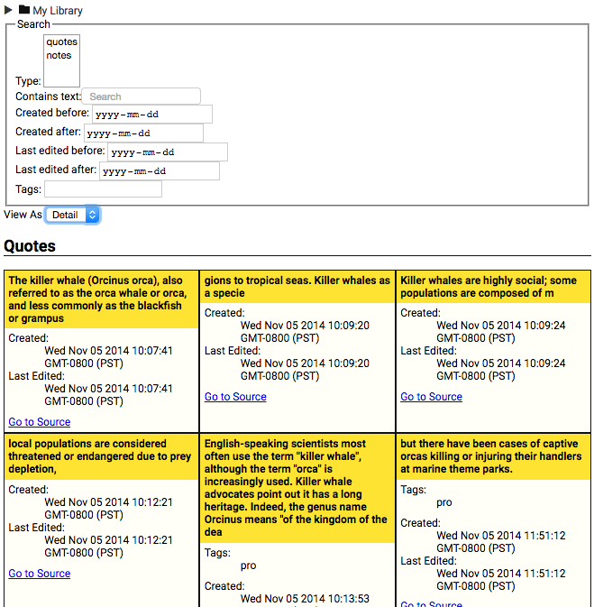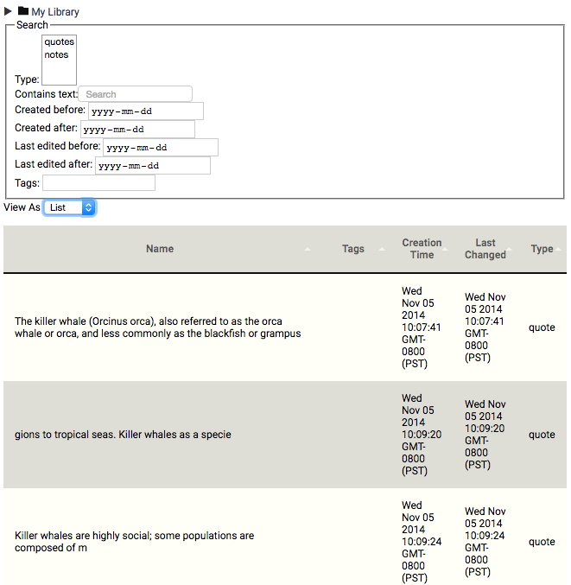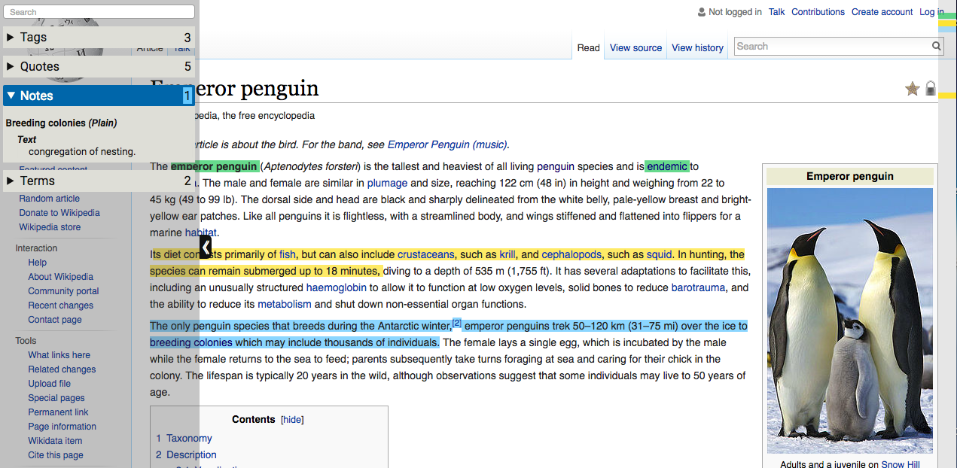

Term you created

Nubs

Gutter

Side Bar

Highlights you made

Note you created

Fold and unfold objects

Click to expand or collapse